Eagle Preserve Donation Form
Help Eagles Soar
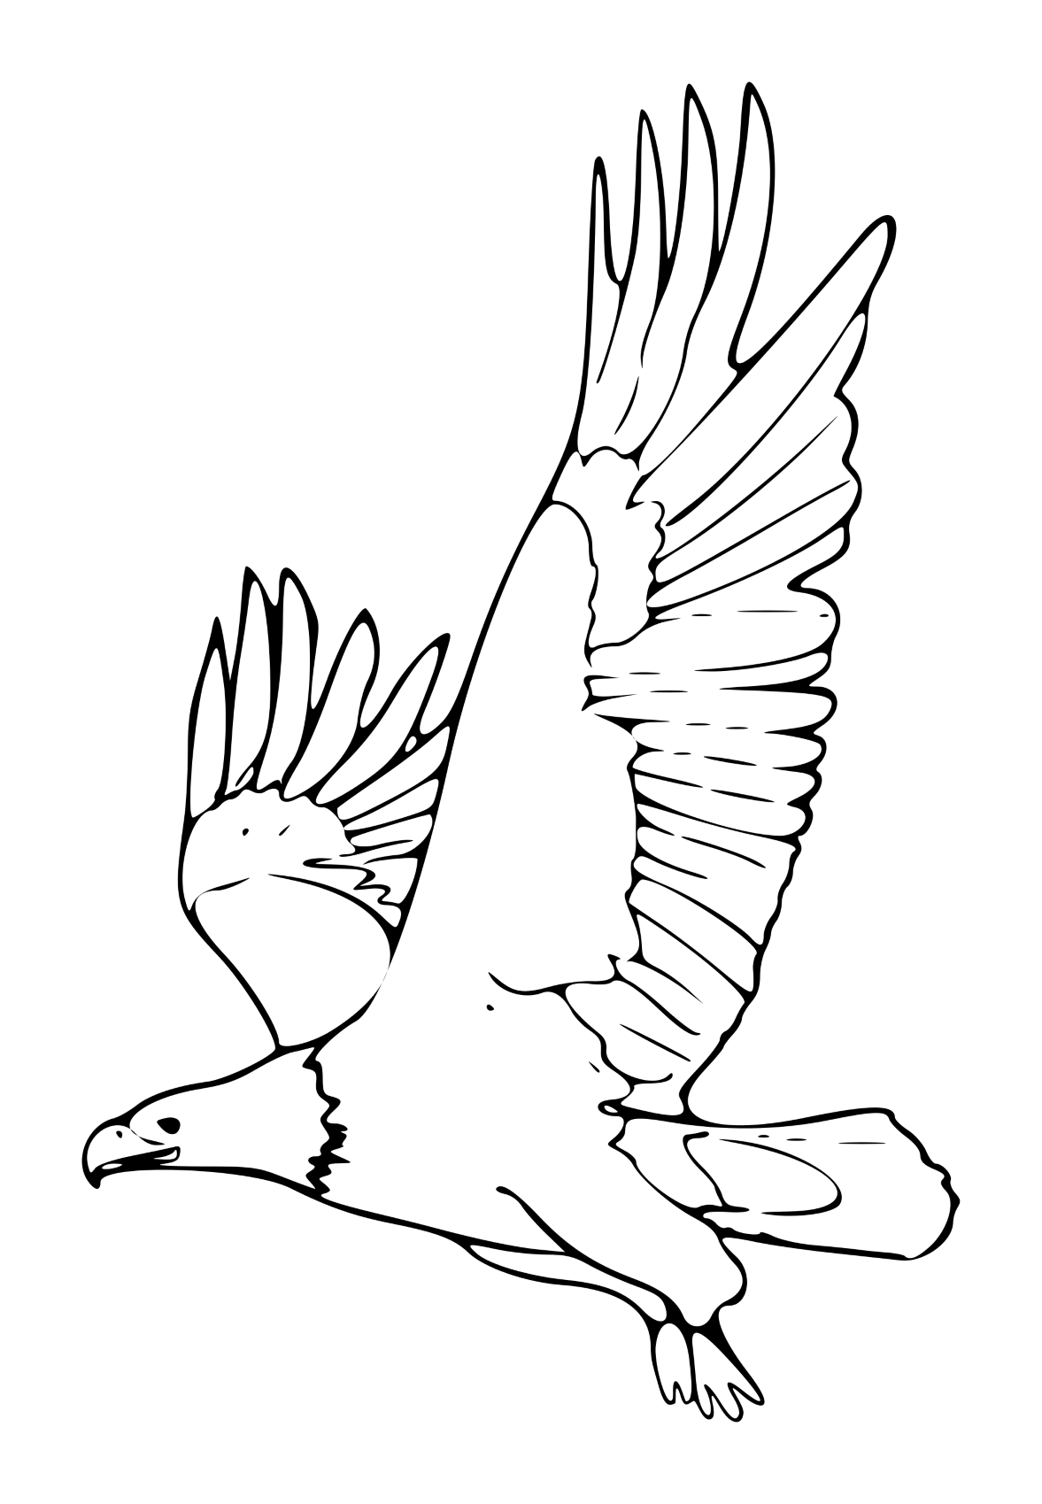

To Donate by Cheque
1. Make cheque payable to: FFCCS Eagle Preserve.
2. Mail cheque AND this donation form to:
PO Box 331, Qualicum Beach, BC, V9K 1S8

To Donate by E-transfer
1. Send e-transfer to: eaglepreserve@shaw.ca
2. Scan and email this donation form to: eaglepreserve@shaw.ca
or mail to: PO Box 331, Qualicum Beach, BC, V9K 1S8
If the French Creek Estuary Land acquisition campaign cannot be completed then funds will be held in an acquisition account to be used for another land acquisition campaign in the French Creek watershed.

First Name____________________ Last Name
Photo by Melanie Leeson

Mailing Address__________________
City______________ Province Postal Code________
Send me updates on the Eagle Preserve Email:
Dedicate Your Donation
In Memory of In Honour of
Please tick the box if you would like your donation to remain anonymous
Charitable tax receipts will be emailed or mailed for donations of $20 or more.
Friends of French Creek Conservation Society (FFCCS) Business No:864877501RR0001
FFCCS will not sell, trade, loan or rent information gathered from this form to others.

Thank you for your generous support!

